Business Process: Meter Work

Contact
Business Process Owner | Billing Operations - Billing Exception Management  Billing Operations – Billing Solutions
Subject Matter Expert(s) | Jose Ortega, Robert Rose, Sarah Plowden
Key Contact | Carol Cerqueda, Maya Duarte
Key Role(s) | Customer Services Representative II
Date Documented | 4/27/2026

Business Process Overview
The Meter Work process defines how SMUD manages Technical Master Data related to device management in support of billing and invoicing within SAP ECC and SAP Industry Solution for Utilities (IS-U) Billing.

This process relies on the Meter-to-Cash technology stack, as outlined in the Standard Billing Business Process Overview (see supporting documents for additional details). The process begins when Billing Operations receives a request to complete Meter Work. Requests may arrive through a variety of channels; however, the predominant mechanism for initiating Meter Work requests is currently Service Notifications, and this dependency should be considered a key input to the process.

Meter Work includes several Technical Master Data activities; however, it is not a comprehensive process. The scope of this process does not include Customer Interconnection Requests, Smart Meter Opt-Out requests, or meter-related activities associated with Contract Billing, including Campus Metering. These processes are covered in their own Business Process Overviews.

The scope of the Meter Work process includes the following activities:
- Address Changes
- Change Meters
- Crossed Meters
- Install Meters
- Meter Change Automation
- New Sets
- Remove Meters

The Meter Work process is considered complete when the required device updates and/or work necessary to support billing have been completed in the Meter-to-Cash systems, enabling customer accounts to proceed through the Standard or Non-Standard billing processes, as applicable.

Business Process Assumptions, Prerequisites, Dependencies
(Assumptions pertaining to the business process)
People | - Assumptions:  - Completed Billing Foundations Training  - Complete Change Meter Training  - Complete Commercial Training  - Prerequisites:  - Provisioned for Billing Roles (SAP ECC/IEE/ UIQ)  - Dependencies:  - Billing Operations Leadership (permission approvals)  - Information Technology (provisioning access)
Process | - Assumptions:  - Billing Received request to complete Meter Work  - Prerequisites:  - N/A  - Dependencies:  - Service Notifications
Technology | - Assumptions:  - See Standard Billing in Support Documents.  - Prerequisites:  - See Standard Billing in Supporting Documents.  - Dependencies:  - See Standard Billing in Supporting Documents.

Process Flowchart
Meter Work Process Mapping As.vsdx
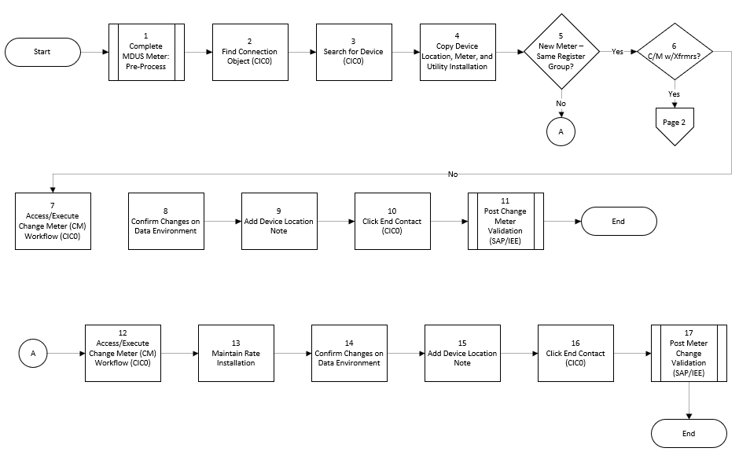

Task Description
Id | Task Description | Procedure
 | See Supporting Documents

Business Rules
Id | Event Name | Business Rules
 | See Supporting Documents

Event | Legal Requirements, Rules, and Regulations  Legal documents/ procedures/ requirements to be fulfilled before/at the specified event.
Id | Event | Legal Requirements, Rules and/or Regulations
 | See Supporting Documents

Pain Points and Improvement Opportunities
Address Changes
- TBD
Change Meter
- Removing Disconnection Locks
- Reverse Change Meter and Reverse Change Meter w/ Transformer processes required multiple transaction codes to complete (workflow would save time and ensure consistent processing)
- Reliance on CIC0 Framework
  - When user exits the CIC0 Change Meter workflow without using the Green Arrow and Ending Contact the configuration does not update IEE
  - Workflow will exit when updating Device Location Notes
  - Adding items to the BDD
- Device Location Notes:
  - Device Location Notes have the PC Editor Issue (where an asterisk is display) if you delete the notes will all group together.
Crossed Meter
- Solar credits cannot be processed directly through Installation Fact Operands.
- As-billed/rebilled calculations require manual Excel workbooks because the needed comparison is not available natively in SAP.
- Time-of-Day (TOD) charge calculations require manual reporting from Itron Enterprise Edition to support billing adjustments.
- kWh usage must be manually entered into Installation Fact Operands, even though the data already exists in SAP ECC; an automated program could eliminate this step.
- Meters must be manually set to non-relevant to bypass Billing Determinant requests after Installation Fact Operands are entered, and then manually returned to relevant status after correction periods are completed.
- Post documents are applied manually via CIC0.
- Necessity to capture screenshots at multiple phases regarding the process to ensure auditability
Install Meter
- TBD
Meter Work
- Device Location notes do not save which leads to incomplete information there appears to be a character limit being imposed without conveying this to the users.
Meter Change Automation
- Dependency on Service Notifications, inability for users to perform Mass Change Meters
- Reliance on CSV extract information not available within source system, as a result CSV extract does not provide intractability
New Set
- Existing New Set process relies upon custom program to update Meter Data Management System (Itron Enterprise Edition) with the Billing Cycle ID. Program does not update consistently as a result exceptions are monitored via the Missing Cycle ID process (see supporting document for additional details)
- Reliance on CIC0 Framework
Remove Meter
- ZAMIIRR transaction does not work with Technically Installed Meters, as a result additional manual steps are required to update Utility IQ (UIQ) when Technically Installed Meters are removed
- IQ09 is required for locating plated devices

Departments impacted by process change (Required)

Department | Type of Change(s) | Action Required
Accounting*
Billing Operations
Contact Center
Field Metering
Geographical Information Systems (GIS)
New Services
Revenue Assurance

Supporting Documentation
(Any subsequent documentation in support of this business process (i.e. business requirements, technical specs, etc.) shall be summarized in the following table.)
Document Type | Link
Blueprint | Cross Meter Blueprint.docx
Blueprint | New Set Metered Blueprint.docx
Blueprint | Remove Meter and Service _MDUS_Blueprint.docx
Business Procedures | Address Changes.pdf
Business Procedures | Cross Meter in SAP.pdf
Business Procedures | Crossed Meter uPerform
Business Procedures | MDUS Conversion and Reversal.pdf
Business Procedures | Meter Change Automation and Exception Process.pdf
Business Procedures | Meter Work.pdf
Business Procedures | Missing Cycle ID Process.pdf
Business Process Overview | Business Process - Crossed Meter (Contact Center).docx
Business Process Overview | Business Process Overview - Standard Billing.docx
Process Map | Address Change Process Mapping As.vsdx
Process Map | Billing Inbox Address Changes.vsdx
Process Map | Cross Meter Process Mapping As Is.vsdx
Process Map | Meter Change Automation Exception Process Mapping As Is.vsd
Process Map | Meter Change Automation Process Mapping As Is.vsd
Process Map | Meter Work Process Mapping As.vsdx
Process Map | New Set Metered Process Mapping As.vsdx
Process Map | Service Crew DS_DT Meter and Service Workflow_To-Be.vsd
Process Map | UC4 EV Process Flow_V4.vsd
Process Map | UC4 MM Process Flow_V4.vsd
Process Map | UC4 MS Process Flow_V4.vsd
Technical Specifications | \\server01\dept-btcm\CCS\Specification_Documents\ETR-Enhancements\ETR-CS363_Meter-Change-Automation.docx
Technical Specifications | \\server01\dept-btcm\CCS\Specification_Documents\ITR-Interfaces\ITR-CS212 New Set Billing Cycle Update.doc

Business Blueprint Amendments

Any subsequent changes to this business process blueprint after the official document approval shall be summarized in the following table. This document must be reprinted and signed by the authorized representatives.
Version | Author | Description of Change | Approval (Name) | Date
1.0 | Joshua Dunn | Initial Draft | Carol Cerqueda | 4/24/2026
 |  |  | Maya Duarte | 4/27/2026

